Module Name: Black-box, White-box testing
Test Case ID: 9
Webpage URL: https://opensource-demo.orangehrmlive.com/?utm_source=chatgpt.com

Scenario ID: 1

Scenario: Valid login
Steps:
1. Open browser
2. Go to website
3. Enter username
4. Enter password
5. click login button

Screenshots: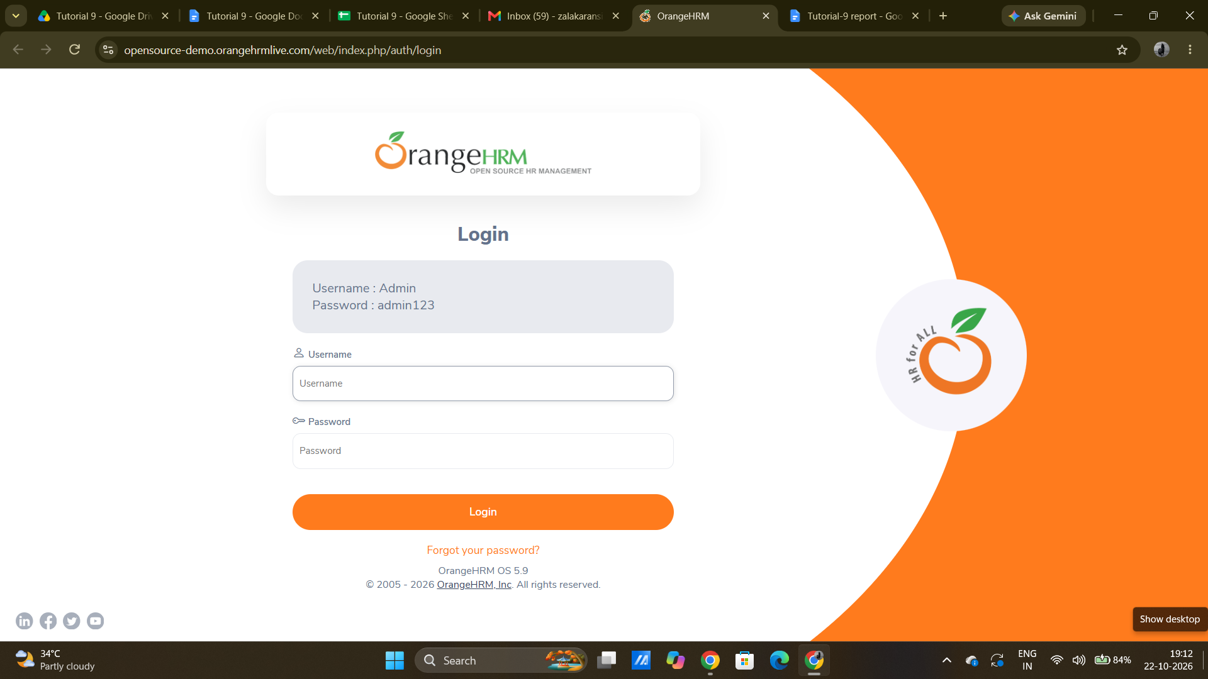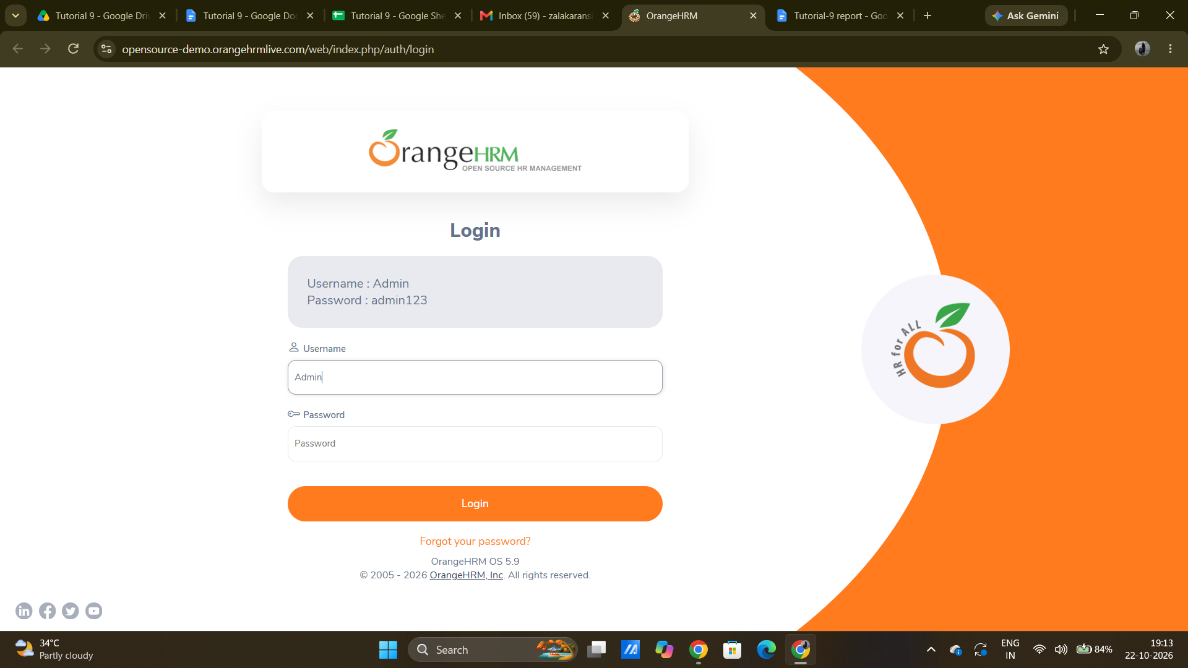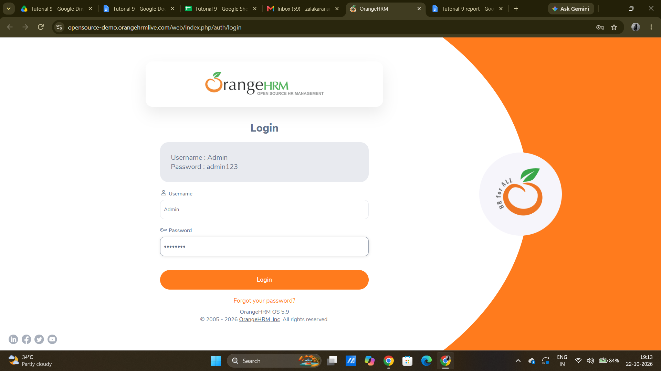

Scenario: Invalid login
Steps:
1. Enter invalid username
2. Enter password
3. tap on login button

Screenshots: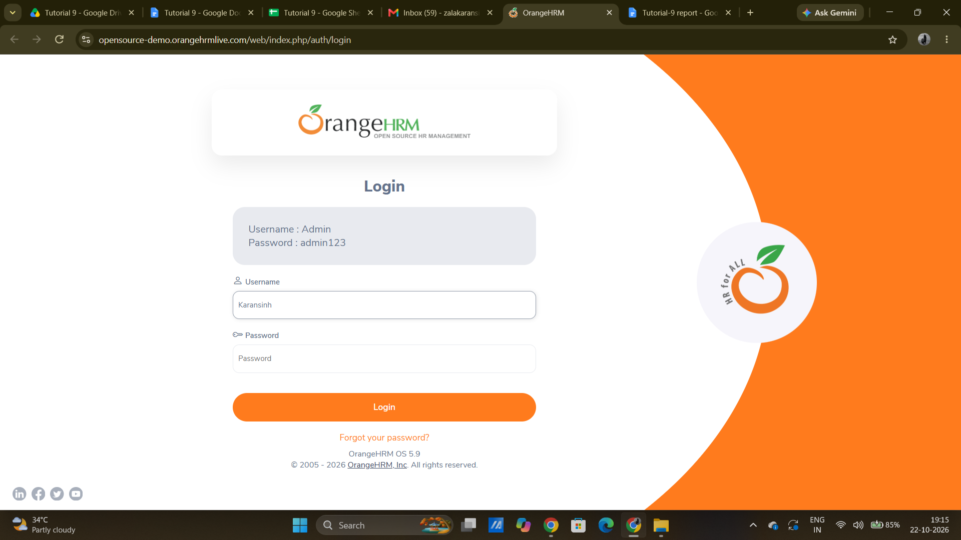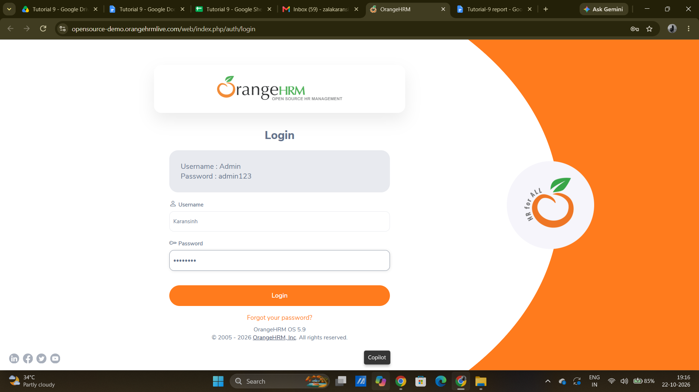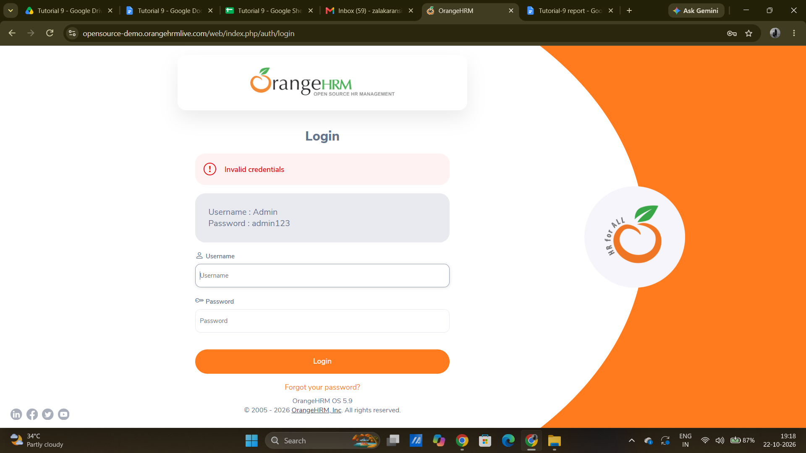Scenario: Invalid login
Steps:
1. Enter username
2. Enter invalid password
3. tap on login button

Screenshots: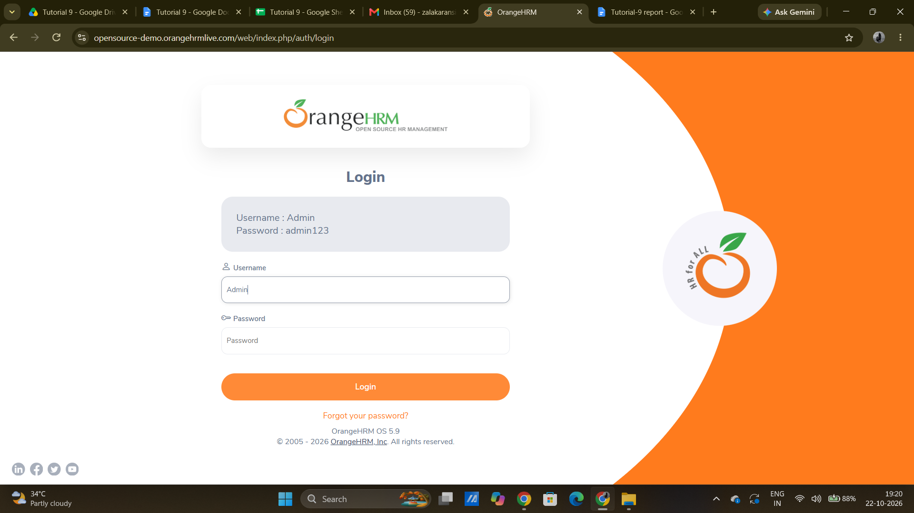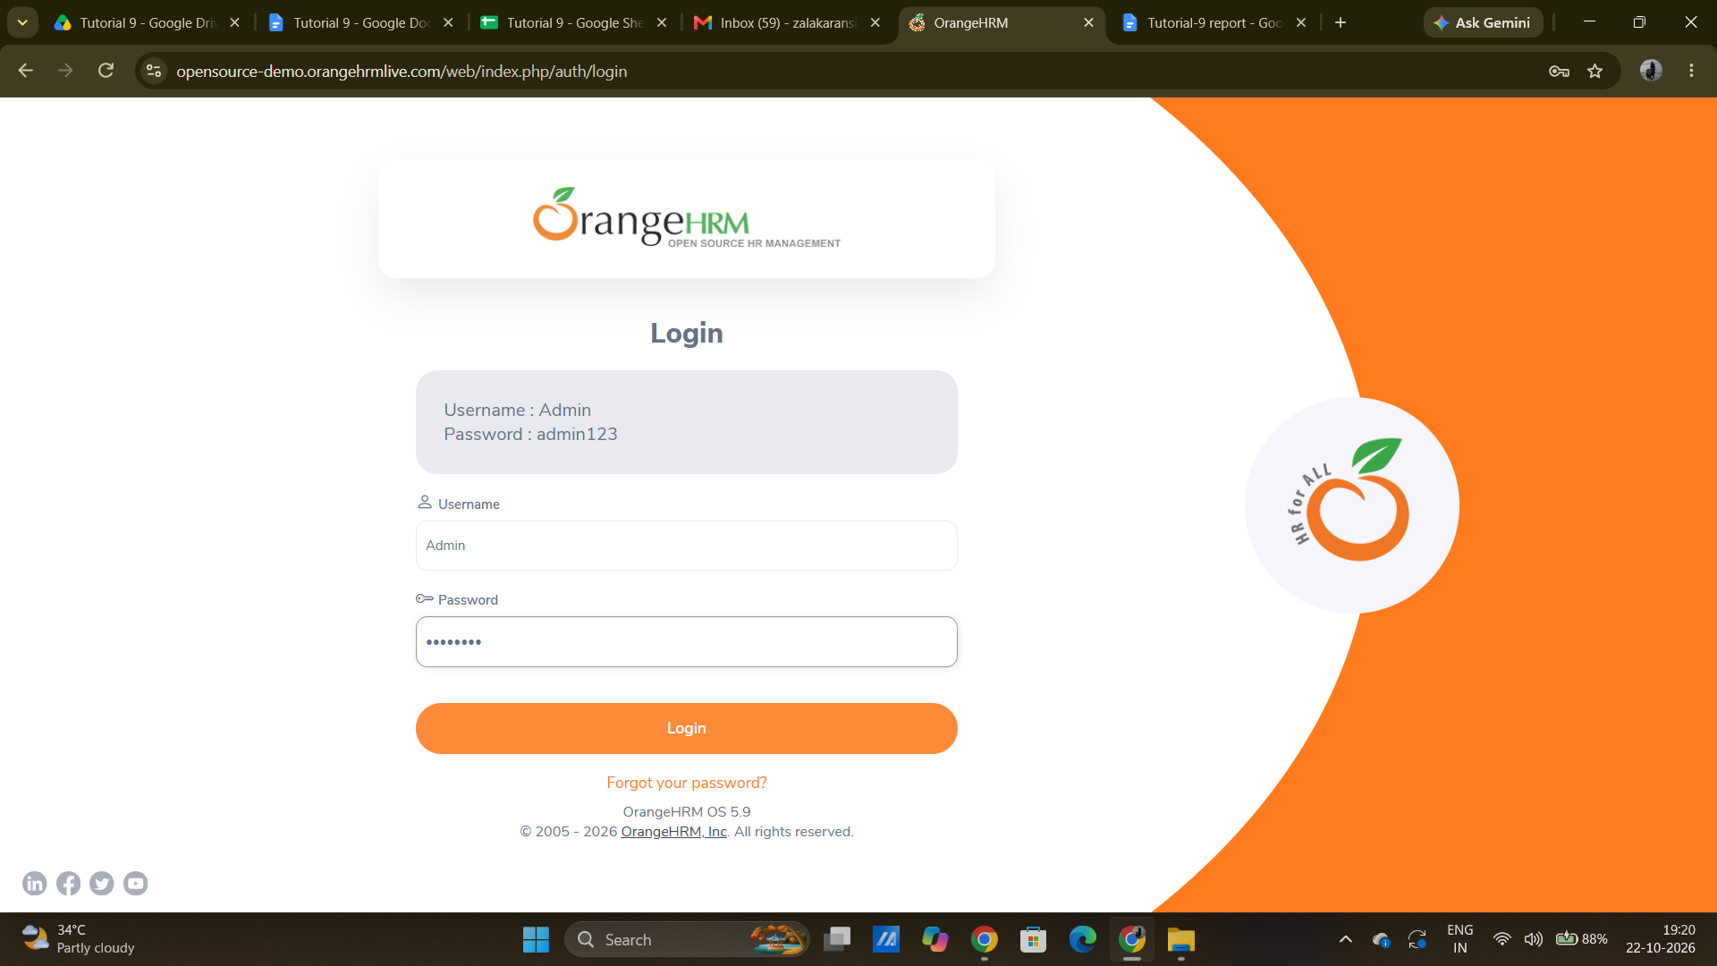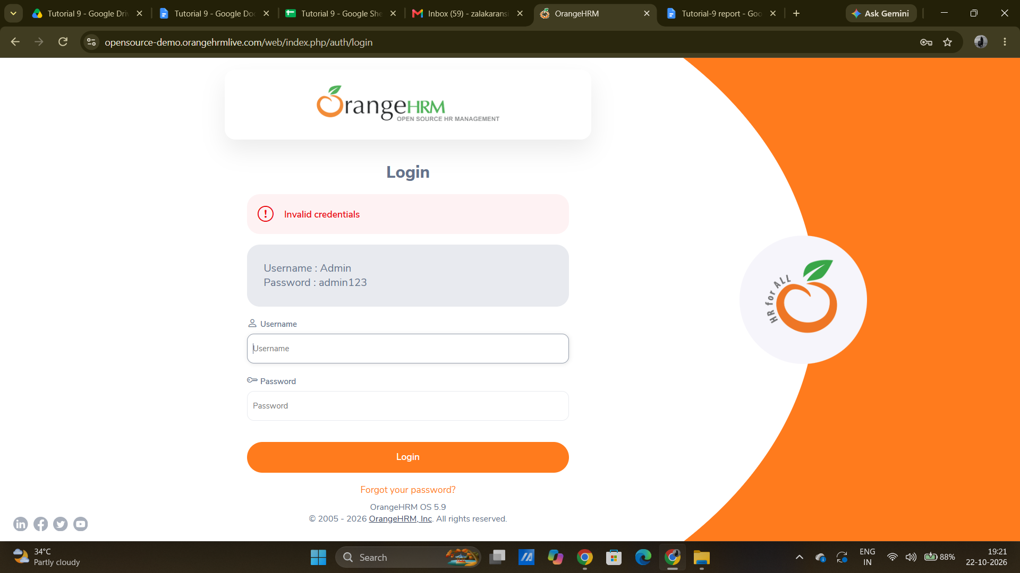Scenario: Blank login
Steps:
1. Enter Blank username
2. Enter Blank password
3. tap on login button

Screenshots: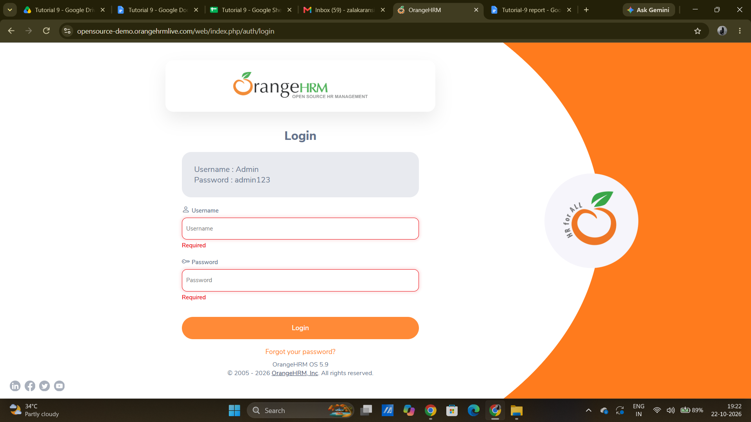Scenario: Employee management
Steps:
1. go to employee
2. click employee management

Screenshots:

